**Chapter 1: Introduction to IoT**

**1.1) Identify the requirements for the real-world problems**

**Introduction to Internet of Things**

Internet of Things (IOT) is the networking of physical objects that contain electronics embedded within their architecture in order to communicate and sense interactions amongst each other or with respect to the external environment. In the upcoming years, IOT-based technology will offer advanced levels of services and practically change the way people lead their daily lives. Advancements in medicine, power, gene therapies, agriculture, smart cities, and smart homes are just a very few of the categorical examples where IOT is strongly established.

Over 9 billion Things (physical objects) are currently connected to the Internet. As of now, in the near future, this number is expected to rise to a whopping 20 billion.

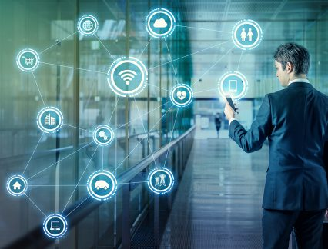

Figure 1.1: Introduction to IOT.

**There are four main components used in IOT:**

1. **Low-power embedded systems–**  
   Less battery consumption, high performance are the inverse factors play a significant role during the design of electronic systems.
2. **Cloud computing–**  
   Data collected through IOT devices is massive and this data has to be stored on a reliable storage server. This is where cloud computing comes into play. The data is processed and learned, giving more room for us to discover where things like electrical faults/errors are within the system.
3. **Availability of big data –**  
   We know that IOT relies heavily on sensors, especially real-time. As these electronic devices spread throughout every field, their usage is going to trigger a massive flux of big data.
4. **Networking-connection–**  
   In order to communicate, internet connectivity is a must where each physical object is represented by an IP address. However, there are only a limited number of addresses available according to the IP naming. Due to the growing number of devices, this naming system will not be feasible anymore. Therefore, researchers are looking for another alternative naming system to represent each physical object.

**There are two ways of building IOT:**

1. Form a separate internetwork including only physical objects.
2. Make the Internet ever more expansive, but this requires hard-core technologies such as rigorous cloud computing and rapid big data storage (expensive).

**IOT USAGE IN DEVICES**

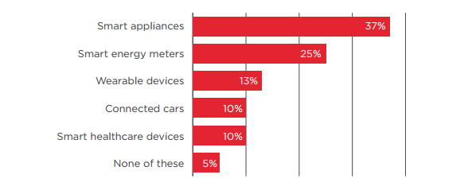

Figure 1.2: GSMA Report.

**Requirements of the real world solved by IOT**

1. **Ability to monitor security** of substations, as well as real-time data on electrical use, and report exceptions so they can be addressed in a timely manner. Ability to solve problems across silos in a utility where IT, Operations and Security don’t talk to each other. Facilitate communications about what’s important.
2. **Any information you need from a device** in order to perform a particular action. Examples provided:
   1. Re-closer on the distribution side of a power line that gets hit by lightening can be closed, checked and reopened by machine after reading the information on the site.
   2. Measure temperature and flow of a pipeline to ensure everything is working as expected or be notified is variances outside the norm are seen.
   3. Solar back-up to devices that may have power or battery issues.
3. **Ability to know how to fix your garage door** because the sensor can tell the company what’s wrong and they can tell you how to fix it. B2B example - a bio-lab is not aware of the volume of enzymes their clients still had on hand. If client ran out, they’d have to put a project on hold for a week or two while more enzymes we made and shipped. They now put one of our devices on every enzyme container so they know which scientist is using which enzyme and when supply is running low. Real-time stock updates enable new bio-lab to optimize the supply chain for their clients.
4. **Communication, collaboration, cohesion and unification of various objects.**Becoming more convenient and connected with the devices we use every day. How to collaborate with devices and work through technology.
5. **Streamlines efficiency and communication of information.**Sensors provide data all the time. Influences decisions by giving you real-time data. Sensors in stores and in manufacturing environments tell you exactly what’s going on and if something is out of the acceptable range you can correct it quickly. Emergency of smaller computers are enhancing communications. We’re taking commodity hardware and optimizing with sensors.
6. All technology starts as a novelty. Becomes a convenience. That’s where IOT is now. **Making it more convenient to control and monitor the 3D printer.** Not yet a pure utility (the end stage for a technology). Ultimately, going forward, things will be built with IOT as a core element, not a special feature. For us, the end point is the printer which can source content from the internet.
7. Industrial internet - **digitization can be applied to the decision making process.**Consumer and healthcare companies will have new apps with connected devices to help save lives and mitigate disasters (e.g., floods, earthquakes).
8. **All IOT solutions solve some problem** - some are smaller, some are bigger. It’s easy to make a lock to connect to the internet. We use cryptography, website and code so the lock doesn’t have to be connected to the internet. Our IOT is not connected to the internet, just the website. As such, the lock cannot be hacked.
9. **Simpler, less expensive home health monitoring** (e.g., scales, blood pressure) to prevent post-surgical events that require return visits to the hospital. Increase adoption and adherence to medication protocols. Opportunity to use data to predict what’s going to happen. Preventive and predictive healthcare.
10. A **connection between humans and computers.** Use Amazon Echo to get all his songs from Amazon Prime and play on demand. Links home management like garage door, lights and HVAC.
11. **Energy saving.** A lot of devices are left on overnight, or longer. Interact with buildings and homes to save energy.
12. **Health devices connected to smart phones diagnose health conditions quickly.** You can take pictures and obtain diagnostics to share with health professionals around the world. Enables the collection and sharing of data in an affordable way. Allows inventors to think about use cases. Digitizes the power grid. Play with how energy is being served. Every device in your house will give you an energy profile. Enterprises will benefit from the digitization of devices and enable the next wave of digitization.
13. Know people that are in the building and **have visibility into what’s going on**. We monitor several thousand conference rooms at Microsoft’s campus to determine if they’re occupied, if A/V is working, what devices people are using, scheduling, booking. We collect data in the cloud to analyze uptime and failure rates. We proactively monitor to see what’s going on. We have statistics about room use and occupancy that will inform and influence the design of the conference rooms on Microsoft’s new campus. In homes, our hub connects all light switches, thermostats, keypads, security system and provides statistics to the cloud so the homeowner can view a dashboard to see how the home is being used. Occupancy use data. We’ll be able to use predictive analytics to make suggestions on how to change the real-time lighting, temp, etc. for your home. Many more touch points - switches, mobile phone, devices, reporting to the cloud versus a single thermostat (Nest) - provide more data for analysis.
14. **Changed the brand cycle.**It used to be 18 to 24 months. Now you must be monitoring social networks to hear what customers are saying and address their concerns or leverage what they are seeing as most beneficial. As John Chambers says, 40% of companies won’t exist in 10 years if they’re not listening to, and responding to the needs of, their customers.
15. **Asset management** - how to engage information to run control systems. Understand the health of the asset producing the work. Know the health and diagnostics of the machine to reduce down time and proactively provide maintenance. Ability to tie the supply chain into the process and provide information back to manufacturing thus reducing costs and expense.
16. **Manufacturers using crowd sourcing to build out their manufacturing floor.** Consumer wireless routers are only secure for a couple of years. Consumer products have a short life expectancy with consumers. Whereas industrial companies need to have an ongoing relationship with their customers since they have service contract and the products often need ongoing service. In healthcare alone IOT has already made incredible contributions saving lives, giving doctors the ability to see a spectrum of health conditions across a large number of people. It will enable more self-care by patients. Clinical trials are now being based on data received from IOT devices thus accelerating time to market. Industrial is incredibly influential because of the buy in from so many big players like IBM, Cisco and GE.
17. **Enables people to try a new approach.** Automate and control things remotely in ways you couldn’t before. Opportunities differ by industry but every industry has many opportunities.
18. We’re at the very early stages but making progress every day. **Getting basic, real-time visibility into places where we haven’t had it before.** For example, we can see a pipeline every half mile and look at KPIs for variances rather than have a human out driving the line and taking measurements. We’ve figured out how to put predictive diagnostics in place. We’re creating a digital twin on the product based on historical performance so we can identify potential needs. IOT provides visibility and reliability where we’ve never had it in the past.

**1.2) Applications of IoT**

**1. IOT Applications – Wearable’s**

Wearable technology is a hallmark of IOT applications and probably is one of the earliest industries to have deployed the IOT at its service. We happen to see Fit Bits, heart rate monitors and smart watches everywhere these days.

One of the lesser-known wearable includes the Guardian glucose monitoring device. The device is developed to aid people suffering from diabetes. It detects glucose levels in the body, using a tiny electrode called glucose sensor placed under the skin and relays the information via Radio Frequency to a monitoring device.

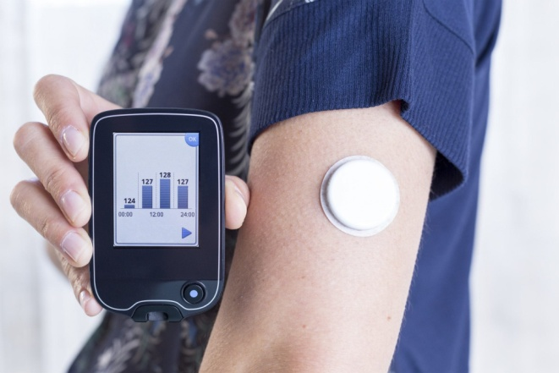

**Figure 1.3:** Guardian glucose monitoring device.

## **2. IOT Applications – Smart Home Applications**

When we talk about IOT Applications, Smart Homes are probably the first thing that we think of. The best example I can think of here is Jarvis, the AI home automation employed by Mark Zuckerberg. There is also Allen Pan’s Home Automation System where functions in the house are actuated by use of a string of musical notes. The following video could give you a better idea.

## **3. IOT Applications – Health Care**

IOT applications can turn reactive medical-based systems into proactive wellness-based systems. The resources that current medical research uses, lack critical real-world information. It mostly uses leftover data, controlled environments, and volunteers for medical examination. IOT opens ways to a sea of valuable data through analysis, real-time field data, and testing. The Internet of Things also improves the current devices in power, precision, and availability. IOT focuses on creating systems rather than just equipment. Here’s how an IOT-enabled care device works.

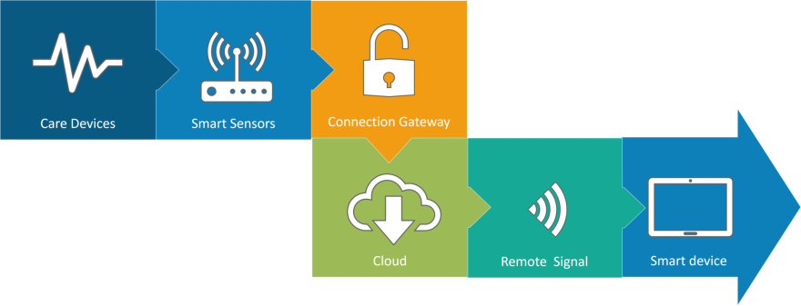

Figure 1.4: IOT enabled care device.

**4. IOT Applications – Smart Cities**

By now I assume, most of you must have heard about the term **Smart City**. The hypothesis of the optimized traffic system as I mentioned earlier, is one of the many aspects that constitute a smart city. The thing about the smart city concept is that it’s very specific to a city. The problems faced in Mumbai are very different than those in Delhi. The problems in Hong Kong are different from New York. Even global issues, like finite clean drinking water, deteriorating air quality and increasing urban density, occur in different intensities across cities. Hence, they affect each city differently. The Government and engineers can use IOT to analyze the often-complex factors of town planning specific to each city. The use of IOT applications can aid in areas like water management, waste control, and emergencies.

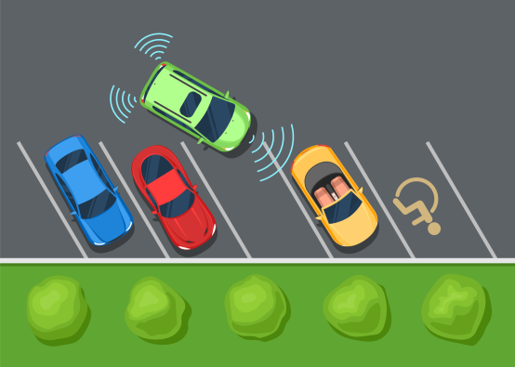

Figure 1.5: IOT based Smart City.

## **5. IOT Applications – Agriculture**

Statistics estimate the ever-growing world population to reach nearly 10 billion by the year 2050. To feed such a massive population one needs to marry agriculture to technology and obtain best results. There are numerous possibilities in this field. One of them is the **Smart Greenhouse**. A greenhouse farming technique enhances the yield of crops by controlling environmental parameters. However, manual handling results in production loss, energy loss, and labor cost, making the process less effective. A greenhouse with embedded devices not only makes it easier to be monitored but also, enables us to control the climate inside it. Sensors measure different parameters according to the plant requirement and send it to the cloud. It, then, processes the data and applies a control action. 

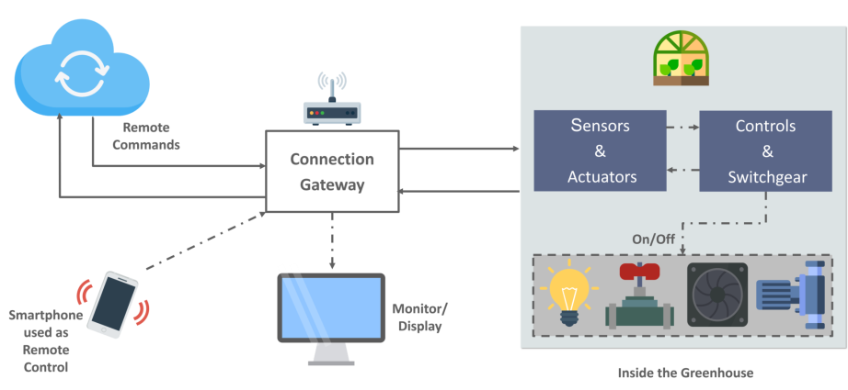

Figure 1.6: Smart Greenhouse.

**6. IOT Applications – Industrial Automation**

This is one of the fields where both faster developments, as well as the quality of products, are the critical factors for a higher Return on Investment. With IOT Applications, one could even re-engineer products and their packaging to deliver better performance in both cost and customer experience. IOT here can prove to be game changing with solutions for all the following domains in its arsenal.

* **Factory Digitalization**
* **Product flow Monitoring**
* **Inventory Management**
* **Safety and Security**
* **Quality Control**
* **Packaging optimization**
* **Logistics and Supply Chain Optimization**

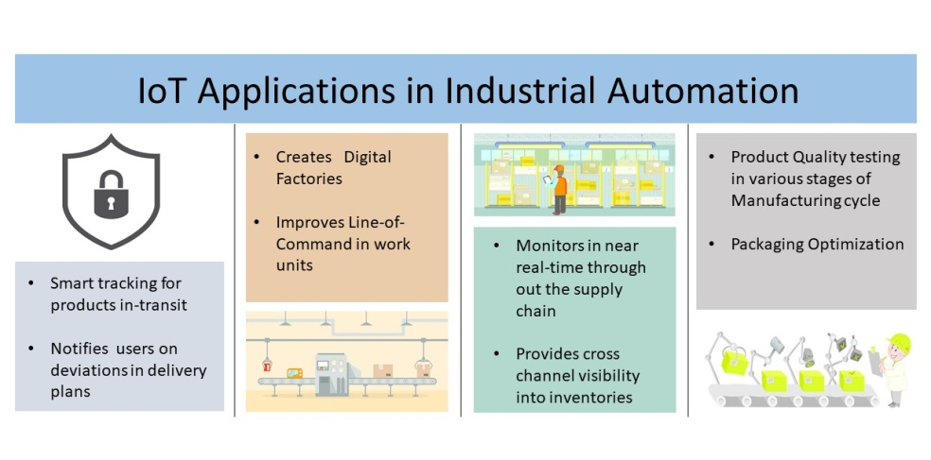

Figure 1.7: Industrial Automation

**Chapter 2: Introduction to Colour Sorting and Count Machine**

**2.1) Problem definition**

Many a times it is seen that in the industry, there is a need to sort products according to colour. For this purpose this project showcases the colour sorting machine. Along with the systematic colour sorting technique, it will also be able to count the number of items produced which is mostly done by other machines in the real world industries. This combination of sensors to implement the colour sorting machine as well as count the number of products that are produced will be a new addition to already existing inventions and can be used as a two in one machine instead of using many bulky, individual and complicated machines.

**2.2) Aims and Objectives**

* The main aim of this project is to sort products according to their colour.
* This will help in an organized segregation of products and simplify further processes involved in manufacturing products.
* In addition to colour sorting, a count of the products that are produced can also be implemented.
* This will ensure a compact method of colour sorting as well as counting the products.
* It is very useful for keeping track of products in large producing industries.

**2.3) Scope**

* Sort objects quickly according to colour.
* It reduces labour cost.
* It reduces manual work.
* It reduces time consumption
* By using IR sensor it can count the number of objects.

**2.4) Features**

* Provides a smooth conveyer for the objects.
* Simplifying the task such as recognizing or differentiating colours.
* Large amount of objects of different colours can be sorted quickly.
* Using servo motors the implementation becomes easy.

**Chapter 3: Review of Literature**

**Introduction to IoT**

The introduction to IoT and the main components of IoT is given in this site. **[1]**

**Applications of IoT**

This site gives the information about the applications i.e. which sectors IoT is used and how it eases a customer’s daily life. **[3]**

**Solving real world problems with IoT**

This site defines what the real world problems are and how it is solved by using IoT. **[2]**

**Introduction to colour sorting**

Why colour sorting machines are more effective than manual sorting mechanisms and how it is useful in industries with bulk production and in industries having repetitive actions is explained. Its applications areas are stated as well. This helped to formulate the problem definition and construct the aims and objectives for this project.

[Extract from site]

As the name suggests, colour sorting is simply to sort the things according to their colour. It can be easily done by seeing it but when there are too many things to be sorted and it is a repetitive task then automatic colour sorting machines are very useful.  These machines have colour sensor to sense the colour of any objects and after detecting the colour servo motor grab the thing and put it into respective box. They can be used in different application areas where colour identification, colour distinction and colour sorting is important. Some of the application areas include Agriculture Industry (Grain Sorting on the basis of colour), Food Industry, Diamond and Mining Industry, Recycling etc. The applications are not limited to this and can be further applied to different industries. **[4]**

**Components required for the implementation of project**

The components required for this project, i.e. Arduino board, 2 Hobbyist Servo Motors, Colour Sensor-TCS3200, power supply as well as the components required for construction of the prototype were given in this article. Along with that, the 3D modelling using Solidworks 3D modelling software was used to show the implementation of the various components, how they work and interact with every other component. The construction of the project as well as a demonstration of how the project works is given in this website.

[Extract from the site]

The working principle is as follows:

* Initially, the coloured skittles which are held in the charger drop into the platform attached on the top servo motor.
* Then the servo motor rotates and brings the skittle to the colour sensor which detects its colour.
* After that the bottom servo motor rotates to the particular position and then the top servo motor rotates again till the skittle drop into the guide rail. **[5]**

**The YouTube video of colour sorting machine**

This is the YouTube video linked to the above website which gives us a demonstration of the project, the 3D modelling of the project, how the project is constructed and also how the code runs to give the desired output. **[6]**

**Aims and objectives of colour sorting machine**

This site gives the aims and objectives of a colour sorting machine as well as how the colour sorter is used to segregate items into separate bins. Also the use of colour sorting machine giving the example of its use in the field of candy industries is also explained. **[7]**

**Counting objects using IR Sensor**

How to count objects using IR Sensor, Code for IR Sensor with Arduino and how 7 Segment display is used in this project to display the count of objects is given in this site. **[8]**

**Code and connections for IR Sensor and theory on sensing of obstacles**

## The working of IR Sensor, its various components, its connections and how the code for counting objects using IR Sensor works is shown in this site. [9]

## Scope of colour sorting

## This site gives us ideas for the scope and applications of this project.

## [Extract from site]

## Applications of Arduino based Color Sorting Machine:

* The color Sorting Machine can be used for Industrial purposes, like sorting different industrial parts according to the colors.
* For sorting skittles, colored balls and M&Ms.
* Can be used in Automobile Industries. **[10]**

**Working of color sensor TCS3200**

How TCS3200 Color Sensor works, its various components, its pin diagram and its connections with Arduino board is shown on this site. **[11]**

**Chapter 4: System Description**

**4.1 Design**

**Block Diagram:**

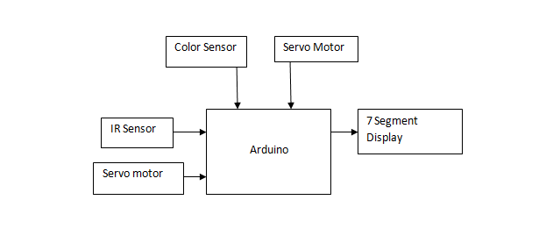

Serial Monitor

Figure 4.1: Block Diagram of Color-Sorting Project

The above block diagram describes how the components of this IoT project will be connected. Two sensors will be used, namely the color sensor TCS3200 which will help detect color of the objects and an IR Sensor which will be used to count the number of objects. These two sensors will be used to accept input. The rotation of the objects towards the color sensor as well as dropping the object in its respective containers using a conveyer will be done using a Servo Motor. The output for the count will be displayed on a 7 segment display and the output for the Color Sensor will be displayed on the serial monitor.

**4.2 Hardware, Software and cloud platforms used**

**Components requirements:**

1. Arduino:

The Arduino MEGA 2560 is designed for projects that require more I/O lines, more sketch memory and more RAM. With 54 digital I/O pins, 16 analog inputs and a larger space for your sketch it is the recommended board for 3D printers and robotics projects. This gives your projects plenty of room and opportunities maintaining the simplicity and effectiveness of the Arduino platform. This document explains how to connect your Mega2560 board to the computer and upload your first sketch. The Arduino Mega 2560 is programmed using the Arduino Software (IDE), our Integrated Development Environment common to all our boards and running both online and offline. For more information on how to get started with the Arduino Software visit the Getting Started page.

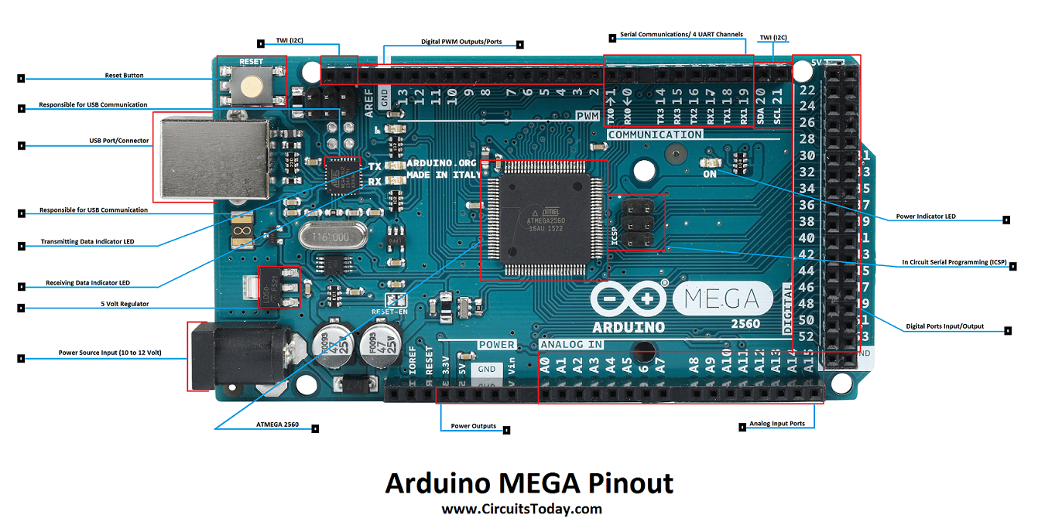 

Figure 4.2: Arduino Mega 2560 hardware Figure 4.3: Arduino Software

2. TCS 3200 Color sensor:

TCS3200-DB Color Sensor Daughterboard is a complete color detector, including a TAOS TCS3200 RGB sensor chip, white LEDs, collimator lens, and standoffs to set the optimum sensing distance. The TCS3200 has an array of photodetectors, each with either a red, green, or blue filter, or no filter (clear). The filters of each color are distributed evenly throughout the array to eliminate location bias among the colors. Internal to the device is an oscillator which produces a square-wave output whose frequency is proportional to the intensity of the chosen color. The applications of color sensor are Test strip reading, sorting by color, Ambient light sensing and calibration, Color matching.

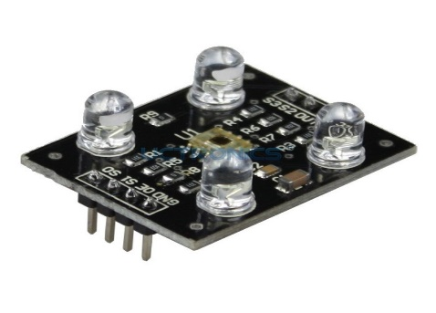

Figure 4.4: Color Sensor TCS3200

3. IR Sensor (LM393)

* Working voltage: 3 - 5V DC
* Output type: Digital switching output (0 and 1)
* 3mm screw holes for easy mounting
* Board size: 3.2 x 1.4cm [4]

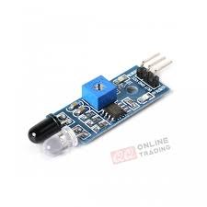

Figure 4.5: IR sensor (LM393)

4. Servo motor:

A servomotor is a rotary actuator or linear actuator that allows for precise control of angular or linear position, velocity and acceleration. It consists of a suitable motor coupled to a sensor for position feedback. It also requires a relatively sophisticated controller, often a dedicated module designed specifically for use with servomotors. Servomotors are not a specific class of motor, although the term servomotoris often used to refer to a motor suitable for use in a closed-loop control system. Servomotors are used in applications such as robotics, CNC machinery or automated manufacturing. The Specifications of servo motor are mentioned below

* Operating voltage: 4.8 V (~5V)
* Operating speed: 0.1 s/60 degree
* Stall torque: 1.8 kgf·cm
* Dead band width: 10 µs
* Temperature range: 0 ºC – 55 ºC [16]

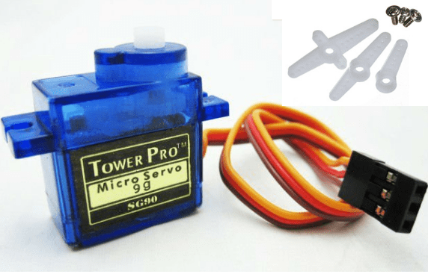

Figure 4.6: Servo Motors

5. Fiber board:

Fiberboard (or fiberboard) is a type of engineered wood product that is made out of wood fibers. Types of fiberboard (in order of increasing density) include particle board or low-density fiberboard (LDF), medium-density fiberboard (MDF), and hardboard (high-density fiberboard, HDF). It is sometimes used as a synonym for particle board, but particle board usually refers to low-density fiberboard. Plywood is not a type of fiberboard, as it is made of thin sheets of wood, not wood fibers or particles. Fiberboard, particularly medium-density fiberboard, is heavily used in the furniture industry. For pieces that will be visible, a veneer of wood is often glued onto fiberboard to give it the appearance of conventional wood. In the packaging industry, the term "fiberboard" is often used to describe a tough Kraft-based paperboard or corrugated fiberboard for boxes. "Fiberboard" is also an intermediate product, an output of a pulp mill used as input for a paper mill.



Figure 4.7: Fiber board

6. Colored objects:

We will be using colored objects for sorting and testing the prototype.



Figure 4.8: Colored Objects

**4.3 Implementation Methodology**

We first observed the problem and planned to implement our project according to it. We also noted various additional things we can add into our project which can make the work of industry owners simple. To implement the color sorting machine and count we followed the following steps:

Step 1: We planned what all facilities are we going to provide the user and gathered all the required hardware and software according to it.

Step 2: Implementing one sensor at a time, we tested our code and saw if we got the desired output. Initially we started with easy to implement sensors like IR Sensor and then went onto implement the color sensor.

* IR Sensor: We have to implement one IR Sensor in this project to count the number of objects being produced. IR Sensor has 3 pins. We connect the IR Sensor to the Arduino Board. Then we burn our code to the Arduino board which executes our logic of counting the number of objects produced. That count is displayed on our serial monitor to keep track of the objects. According to our logic implemented,

0 objects → count is not affected.

1 or more object → the number of objects is counted.

* Color Sensor: We have to implement one color sensor in our project which will check the color of the object and help us in sorting objects produced in bulk. The code is run on Arduino board which executes the logic of how the objects are sorted. The sensor sorts 3 colors namely red, blue and green. Accordingly the object is sent to respective bin.

Logic:-

|  |  |  |
| --- | --- | --- |
| S2 | S3 | Color Detected |
| LOW | LOW | RED |
| HIGH | HIGH | GREEN |
| LOW | HIGH | BLUE |

Table 4.1: Logic Table for Color Sensor

Step 3: Building the Prototype:

* First we bought the fiber board and cut it into pieces of respective size.
* Then we decided the placement of the respective sensors.
* First we fixed the IR Sensor which would help us count the number of objects
* Then the color sensor was placed.
* We tested and inserted the Servo Motors for the conveyer.
* We kept respective bins for the colored objects.

**4.4 Hardware circuit diagram**

**4.5 Code**

**Code for IR Sensor:-**

To count the number of objects using IR Sensor.

Display is shown on the serial monitor in arduino

Code for IR Sensor:

int LED = 13; // Use the onboard Uno LED

int obstaclePin = 7; // This is our input pin

int hasObstacle = HIGH; // HIGH MEANS NO OBSTACLE

int counter = 0;//initialize counter as 0

int i = 0;

void setup() {

pinMode(LED, OUTPUT);

pinMode(obstaclePin, INPUT);

Serial.begin(9600);

}

void loop() {

hasObstacle = digitalRead(obstaclePin); //Reads the output of the obstacle sensor from the 7th PIN of the Digital section of the arduino

if (hasObstacle == LOW) //LOW means something is ahead, so illuminates the 13th Port connected LED

{

Serial.println("Stop something is ahead!!");

counter = counter+1;

Serial.println(counter);

digitalWrite(LED, HIGH);//Illuminates the 13th Port LED

}

else

{

Serial.println("Path is clear");

digitalWrite(LED, LOW);

}

delay(200);

}

Code for Color Sensor TCS3200

// TCS230 or TCS3200 pins wiring to Arduino

#define S0 4

#define S1 5

#define S2 6

#define S3 7

#define sensorOut 8

// Stores frequency read by the photodiodes

int redFrequency = 0;

int greenFrequency = 0;

int blueFrequency = 0;

void setup() {

// Setting the outputs

pinMode(S0, OUTPUT);

pinMode(S1, OUTPUT);

pinMode(S2, OUTPUT);

pinMode(S3, OUTPUT);

// Setting the sensorOut as an input

pinMode(sensorOut, INPUT);

// Setting frequency scaling to 20%

digitalWrite(S0,HIGH);

digitalWrite(S1,LOW);

// Begins serial communication

Serial.begin(9600);

}

void loop() {

// Setting RED (R) filtered photodiodes to be read

digitalWrite(S2,LOW);

digitalWrite(S3,LOW);

// Reading the output frequency

redFrequency = pulseIn(sensorOut, LOW);

// Printing the RED (R) value

Serial.print("R = ");

Serial.print(redFrequency);

delay(100);

// Setting GREEN (G) filtered photodiodes to be read

digitalWrite(S2,HIGH);

digitalWrite(S3,HIGH);

// Reading the output frequency

greenFrequency = pulseIn(sensorOut, LOW);

// Printing the GREEN (G) value

Serial.print(" G = ");

Serial.print(greenFrequency);

delay(100);

// Setting BLUE (B) filtered photodiodes to be read

digitalWrite(S2,LOW);

digitalWrite(S3,HIGH);

// Reading the output frequency

blueFrequency = pulseIn(sensorOut, LOW);

// Printing the BLUE (B) value

Serial.print(" B = ");

Serial.println(blueFrequency);

delay(100);

}

**4.6 Final Prototype**

**4.7 Conclusion and Future scope of the project**

**Conclusion:**

The proposed project provides a color sorting machine with the ability to also count the number of objects produced. This helps us have a two in one machine and the working of this model is much easier as compared to other bulky industrial machines due to its features and compact size.

**Future Scope:**

* A robotic arm can be used to pick and place objects which can make the working of the project faster.
* The sensors can be modified to not only match the needs of color sorting but also distinguish between various other objects.
* It can be made more durable by using better quality materials.
* Large industries associated with color sorting can use this project to reduce bulky machinery in their workspace causing the working area to be more organized and provide larger amount of space for mobility.

**4.8 Constraints for real time deployment**

* Arduino Board: Even though this project could be implemented with Arduino Mega board, it is a small scale project. If this project is to be implemented on a large scale, the Arduino Mega board will fall short due to less number of pins and processing capabilities.
* IR Sensor: IR sensors used here have a small capability of detecting objects and they have a small range to detect objects in the environment. For large scale, IR sensors with a greater detection range and performance will have to be used.
* Cost: If this machine needs to be implemented in a real time industry, the net cost will be much higher.
* Sorting objects: In this project only particular objects can be sorted keeping in mind the size and other specifications of the objects.

**REFERENCES**

|  |  |
| --- | --- |
|  | **Introduction to IoT** |
| 1 | https://www.google.com/url?q=https%3A%2F%2Fwww.geeksforgeeks.org%2Fintroduction-to-internet-of-things-iot-set-1%2F&sa=D&sntz=1&usg=AFQjCNGsZEe2MVCdy-G8BpMEWwfbZvVNwg |
| 2 | https://www.google.com/url?q=https%3A%2F%2Fwww.linkedin.com%2Fpulse%2F20-real-world-problems-solved-iot-c-thomas-tom-smith-iii&sa=D&sntz=1&usg=AFQjCNGI9d3-Jx_5c545-QNkD1w66AWALg |
| 3 | https://www.google.com/url?q=https%3A%2F%2Fwww.edureka.co%2Fblog%2Fiot-applications%2F&sa=D&sntz=1&usg=AFQjCNHAbcFe4eDCZ-Ce_Rl6DakoSDVfpw |
|  | **Introduction to Colour Sorting Machine** |
| 4 | <https://circuitdigest.com/microcontroller-projects/arduino-color-sorter-machine-using-tcs3200-color-sensor> |
| 5 | <https://howtomechatronics.com/projects/arduino-color-sorter-project/> |
| 6 | <https://www.youtube.com/watch?v=g3i51hdfLaw> |
| 7 | <https://nevonprojects.com/iot-color-based-product-sorting-machine-project/> |
| 8 | <https://www.playembedded.org/blog/an-object-counter-using-an-ir-sensor-and-arduino/> |
| 9 | <http://surajpassion.in/ir-obstacle-sensor-with-arduino/> |
| 10 | <https://www.mepits.com/project/274/embedded-projects/arduino-based-color-sorting-machine> |
| 11 | <https://randomnerdtutorials.com/arduino-color-sensor-tcs230-tcs3200/> |